POP/IMAP email account in Microsoft Outlook
1.Create a new mail account
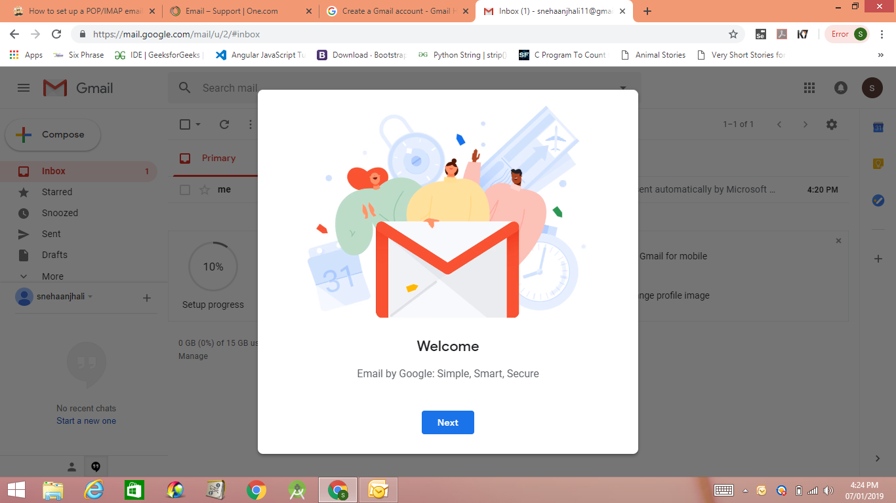
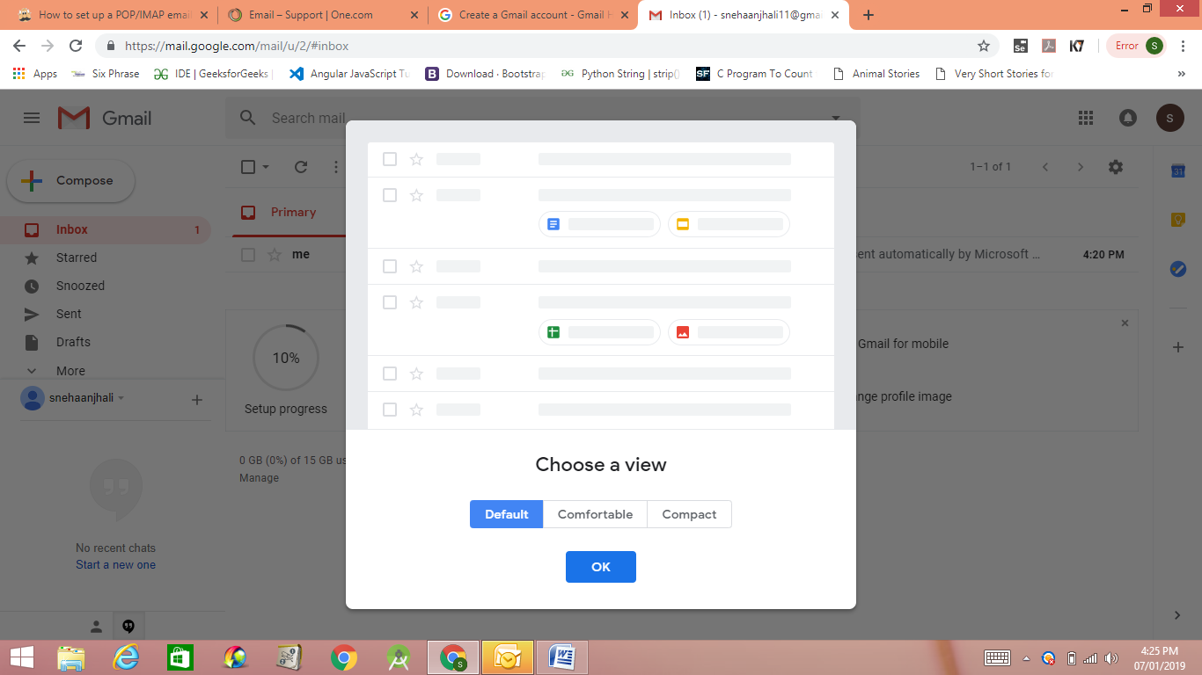

2.In MsOutlook 2007,Click the File tab at the top of the window and in the Info category, click the Add Account button.
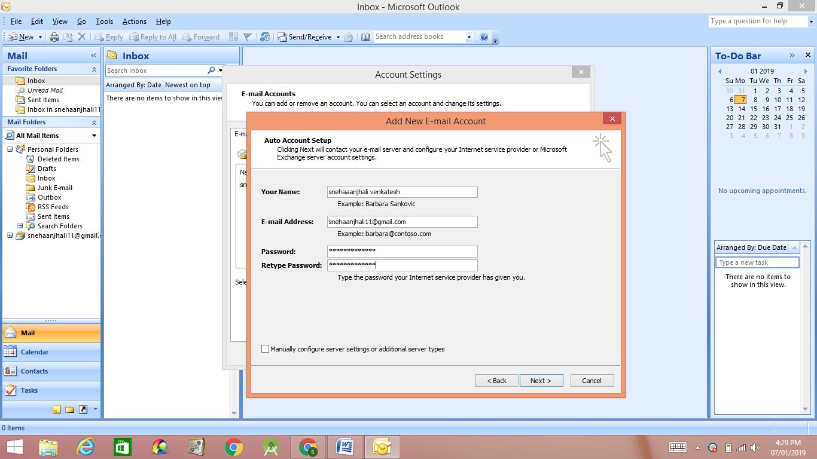
In the Add an Email Account wizard displayed, you’ll be asked Do you want to set up Outlook to connect to an email account? Ensure the radio button next to Yes is selected, then click Next.
In Account Setup panel, enter the following details:
- Your Name: Enter the name you’d like to appear on your emails.
- Email Address: Your full email address.
- Password: Your email account password.
- Retype Password: Enter your email account password again.

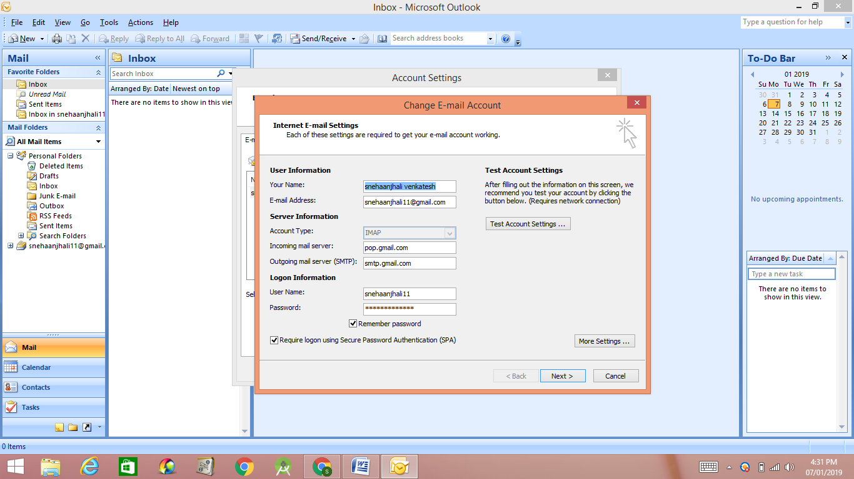
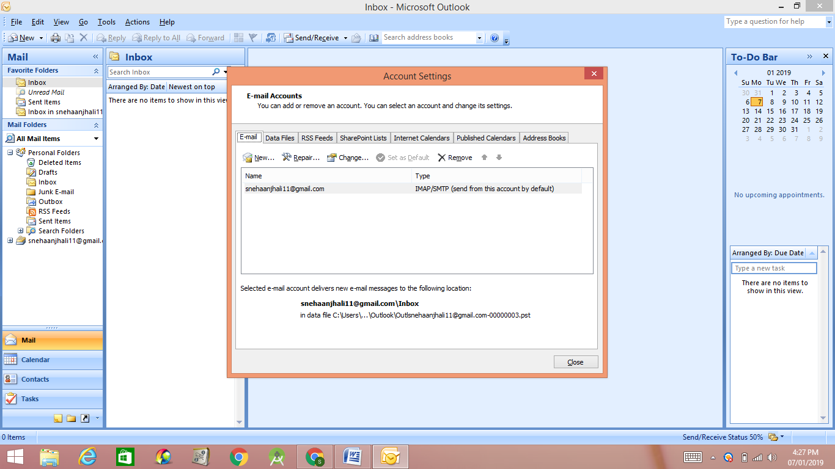
Enter the following details:
- Your Name: Enter the sender’s name you’d like to appear on your emails.
- Email Address: Your full email address.
- Account Type: Use the dropdown menu to select POP3 or IMAP.
- Incoming mail server: For POP or IMAP accounts use mail.yourdomain.tld if you’re on shared plan (replace yourdomain.tld with your actual domain) or mail.papamail.net if you use Basic/Advanced Email services.
- Outgoing mail server (SMTP): For POP or IMAP accounts use mail.yourdomain.tld if you’re on shared plan (replace yourdomain.tld with your actual domain) or mail.papamail.net if you use Basic/Advanced Email services.
- User Name: Your email account username.
- Password: Your email account password.

Now click the More Settings… button. In the Internet Email Settings window that opens, select the Advanced tab.
Enter the following details:
- Incoming server: Ensure the default port is set to 995 for POP accounts, or 993 for IMAP accounts. Click the checkbox next to This server requires an encrypted connection (SSL).
- Outgoing server (SMTP): Change the default port (25) to 465 for POP or IMAP accounts. Use the dropdown menu next to Use the following type of encrypted connection to select SSL.

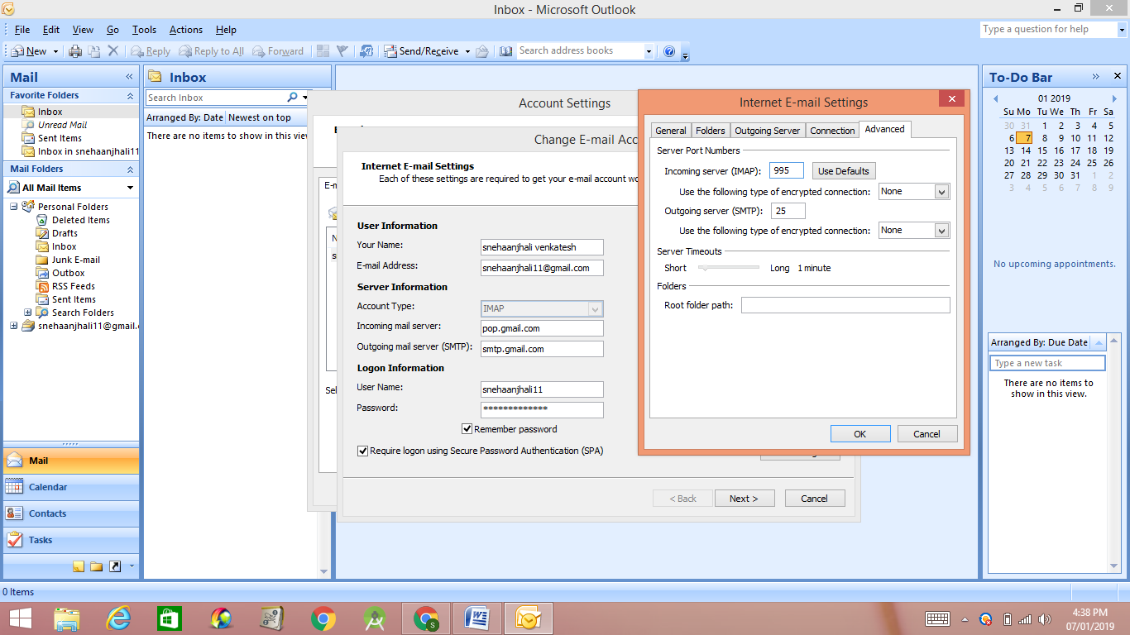

Switch to the Outgoing Server tab. Check the box next to My outgoing server (SMTP) requires authentication, then click the radio button next to Use same settings as my incoming mail server.
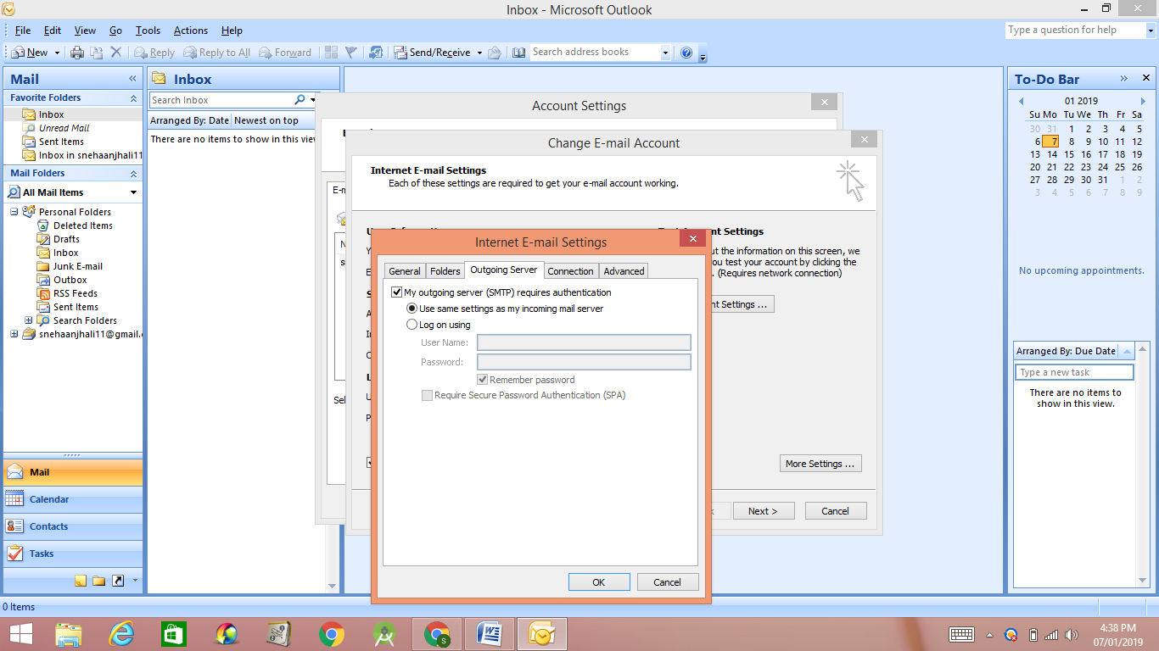
Click OK to close the Internet E-mail Settings window. In the POP and IMAP Account Settings window, click the Test Account Settings…button to ensure Outlook can communicate with your email server. 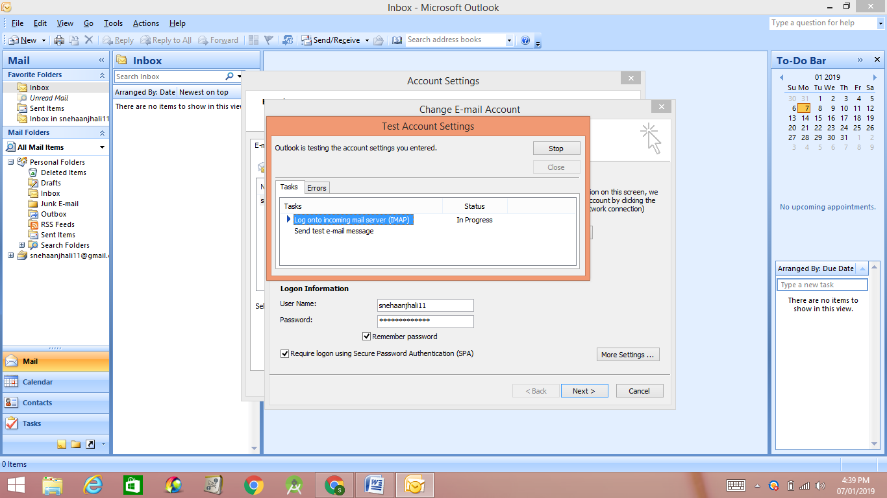

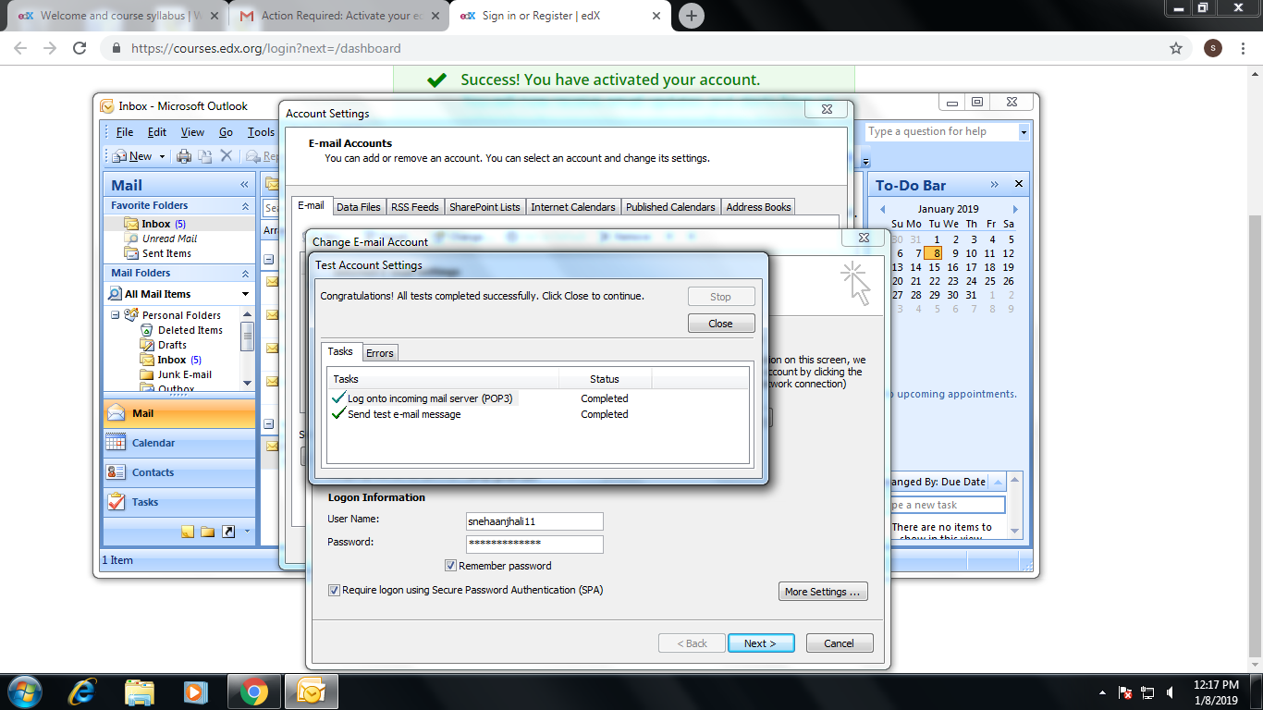
Once the test completes successfully, click Next and then Finish to wrap up.
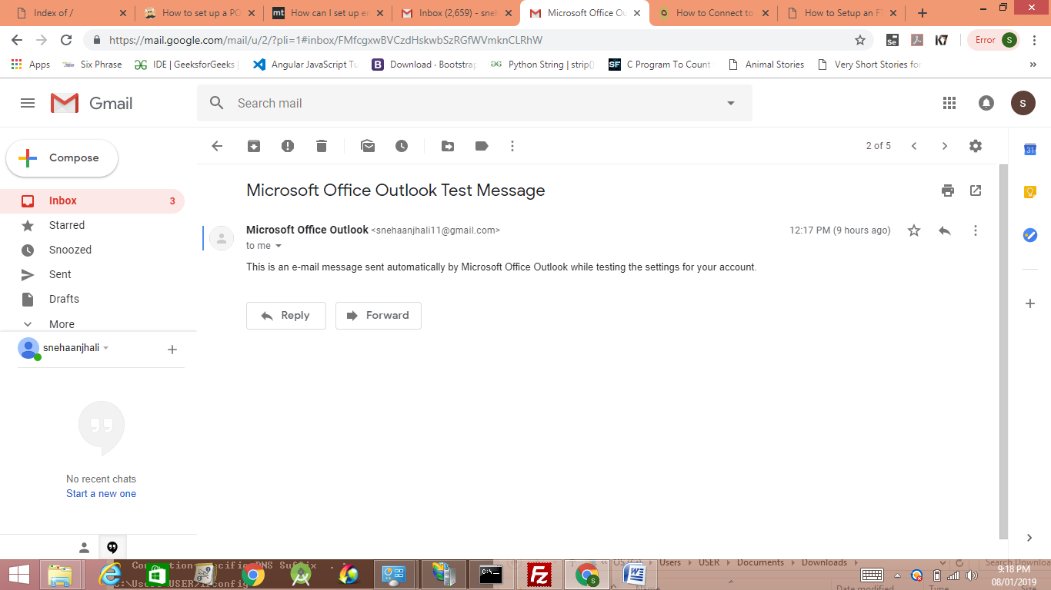

Create an FTP Server using FileZilla

Click on Start, Control Panel and go to Add/Remove Programs. Then click on Add/Remove Windows Components. For Windows 7 and higher, click on Programs and Features from Control Panel and then click on Turn Windows features on or off.

In the components wizard, scroll down until you see IIS in the list and check it off. Before you click Next though, make sure you click on Details and then check File Transfer Protocol (FTP) Service.

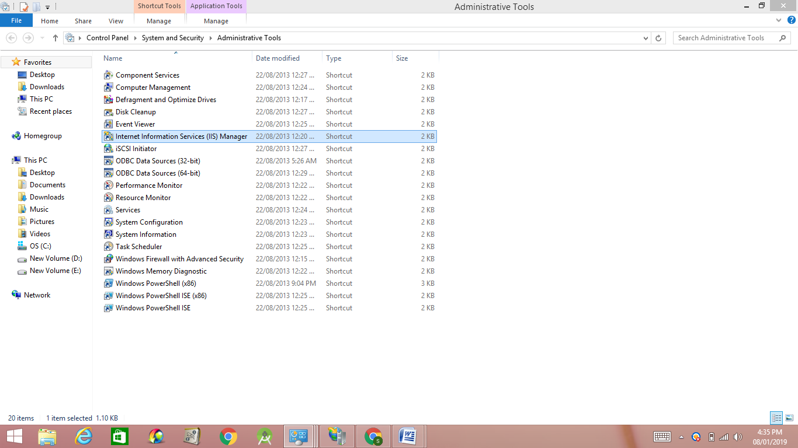
go ahead and click on the box next to Internet Information Services and FTP Server. You also need to make sure you check the Web Management Tools box otherwise you won’t be able to manage IIS from Administrative Tools later on. For FTP, you need to check the FTP Service box otherwise you won’t have the option to create an FTP server. Click OK and then click Next. Windows will go ahead and install the necessary IIS files along with the FTP service.
Once IIS has been installed, you may have to restart your computer. Now we want to go ahead and open the IIS configuration panel to set up the FTP server. So go to Start, then Control Panel and click on Administrative Tools. You should now see an icon for Internet Information Services.

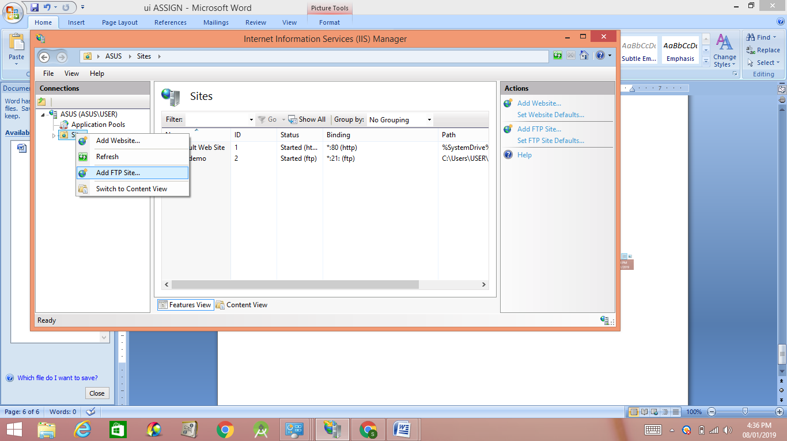
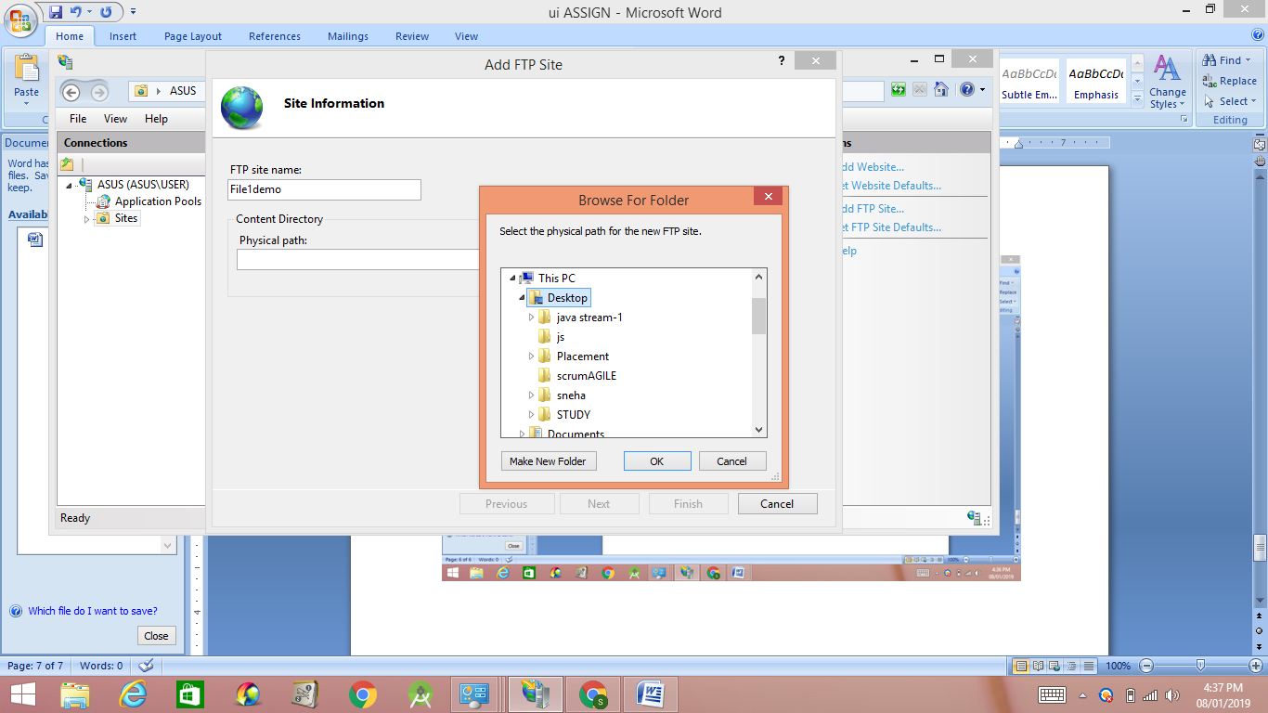

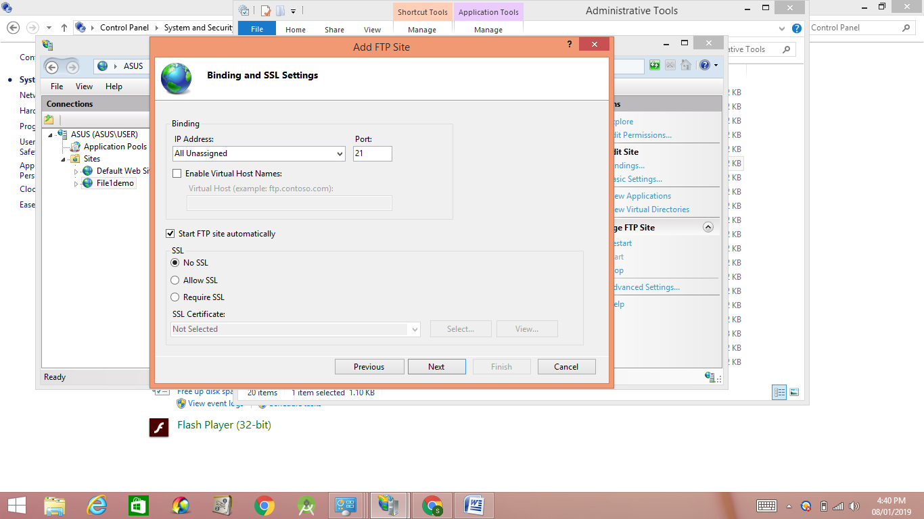
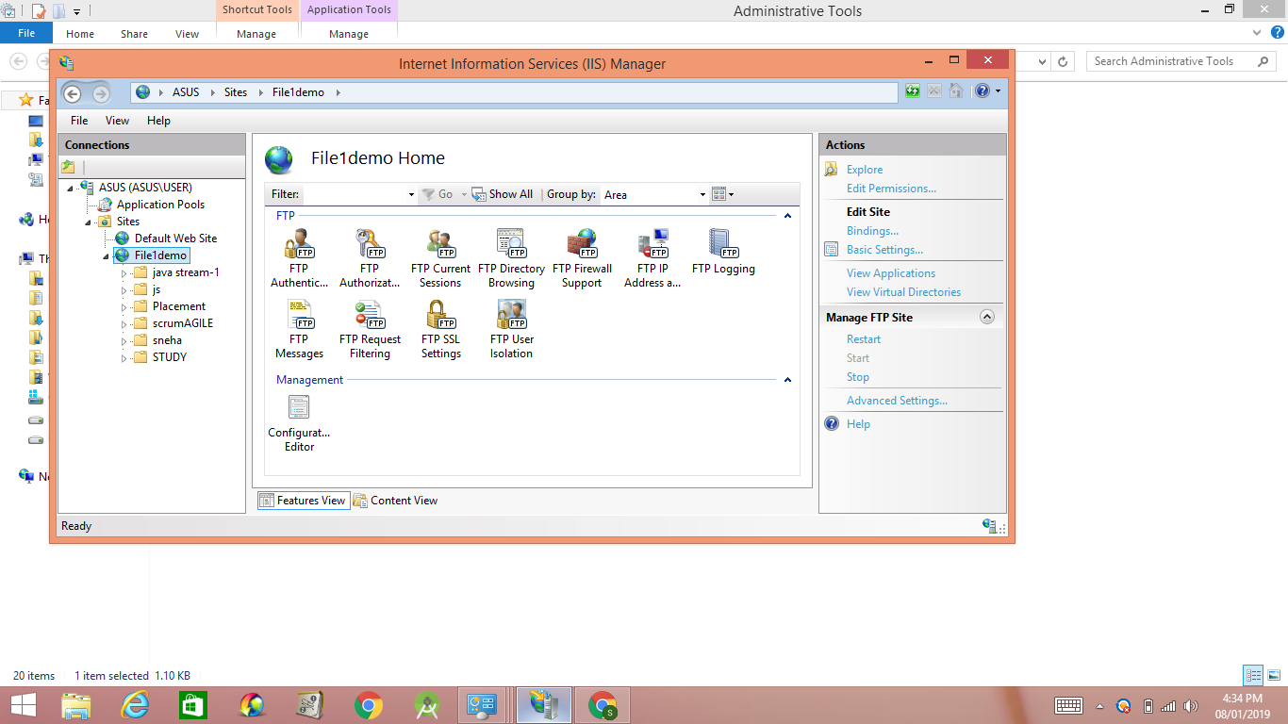

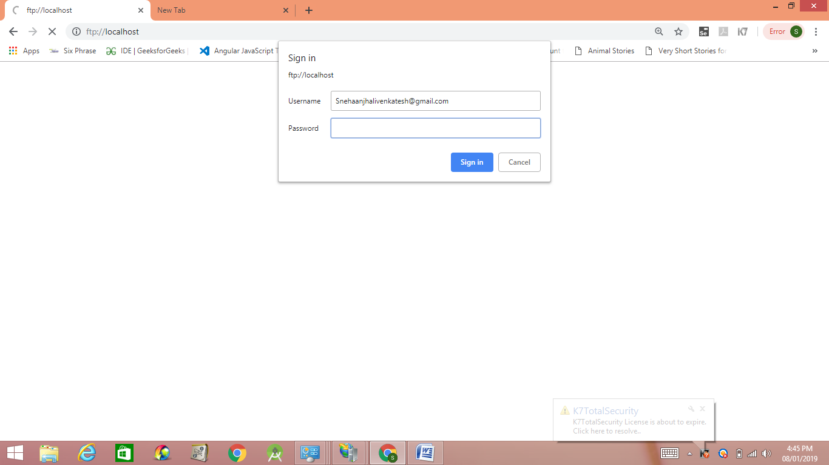

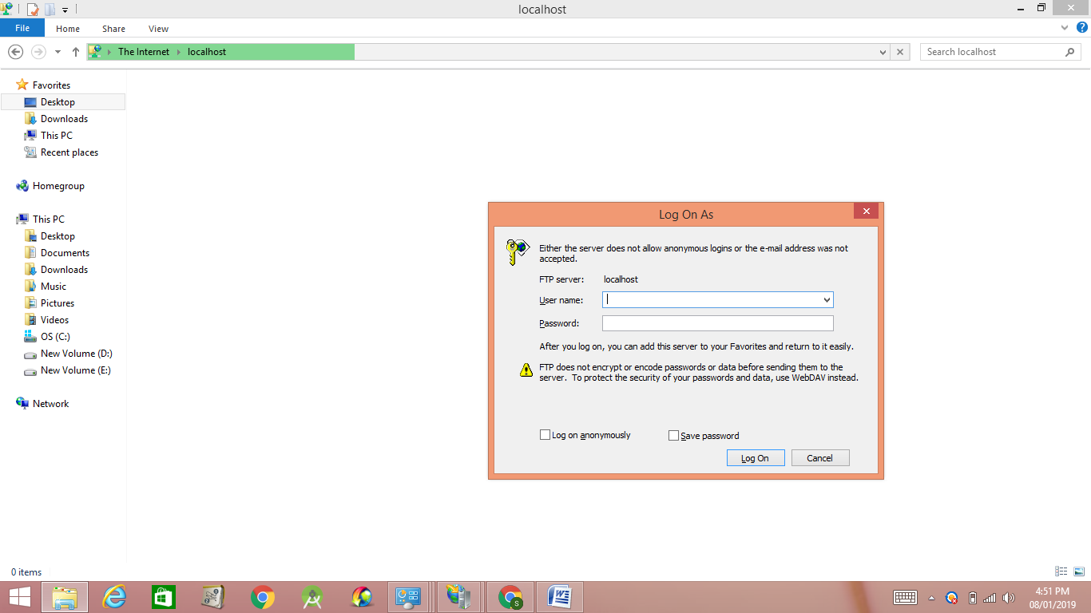

Download the server program from this URL: http://filezilla-project.org.

Install FileZilla
The server software is actually very easy to install. Some of the screens are complicated, but you don’t have to worry because you can just go with the defaults and everything works fine.
On the Startup settings screen, you can stick with the defaults or change the admin port if you like. This port is only used to administer the server, not for FTP clients.

Configure FileZilla Server
Once connected to the server, you’ll get a screen like below. It’ll give you some basic info about the server and also auto-detect if you are behind a NAT router.
The first thing that you will need to do is create an FTP user account. Click the Edit menu and choose Users:
On the General page, go ahead and click on the Add button at the far right.
Enter the name of the user then hit OK:
To assign a password, check the Password box and then type in a password for the use.
We’re done adding a user. Now to share a directory click “Shared folders” then browse for the folders that you want to share:
Set the permission for the users, make sure to uncheck write and delete if you don’t want other users to modify your files and directories.

Server Side:
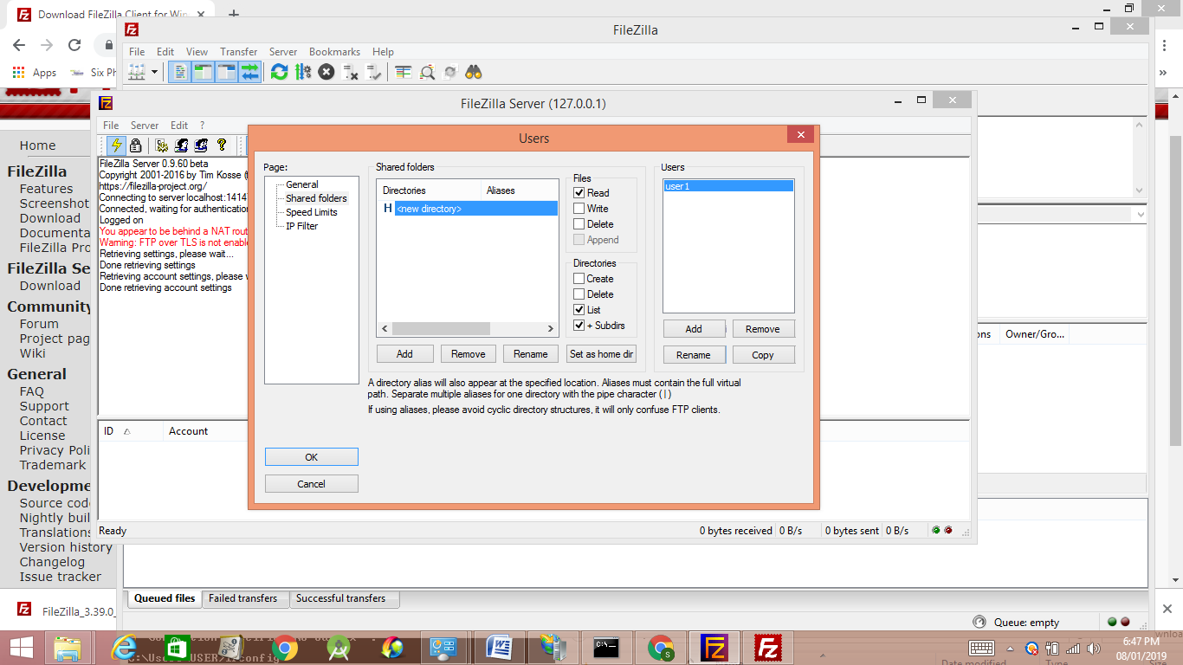
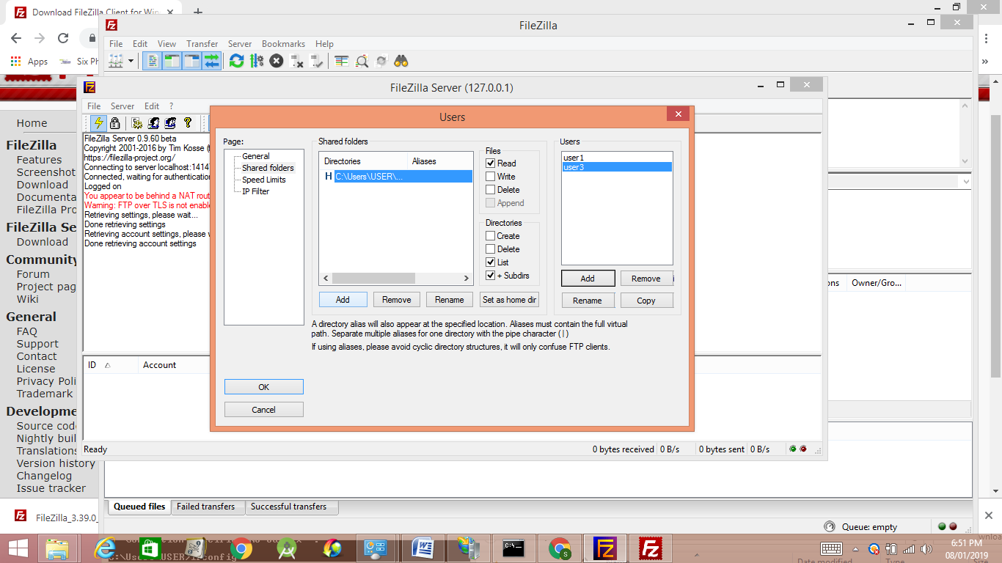

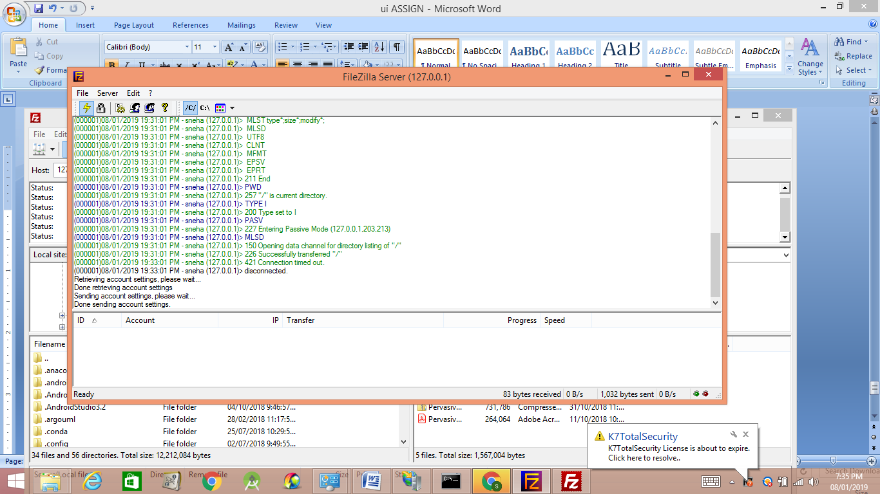
Client side:
- FTP server name: enter your domain name here or the name of the hosting server where your account resides (e.g. siteground200.com)
- FTP username: your cPanel username
- FTP password: your cPanel password
- Port: The default FTP port is 21. You an also leave this field empty to use the default port.
When ready click “Quickconnect”. When you connect successfully, you’ll see a note in the status area at the top of your screen indicating that you are connected. The files and folders on your own computer will appear under the “Local Site” pane on the left side of your screen. Your Web Hosting account files and folders will appear in the “Remote Site” pane on the right. You can now transfer files and folders between your local computer and your hosting account by dragging them from the left pane to the right.

local site:
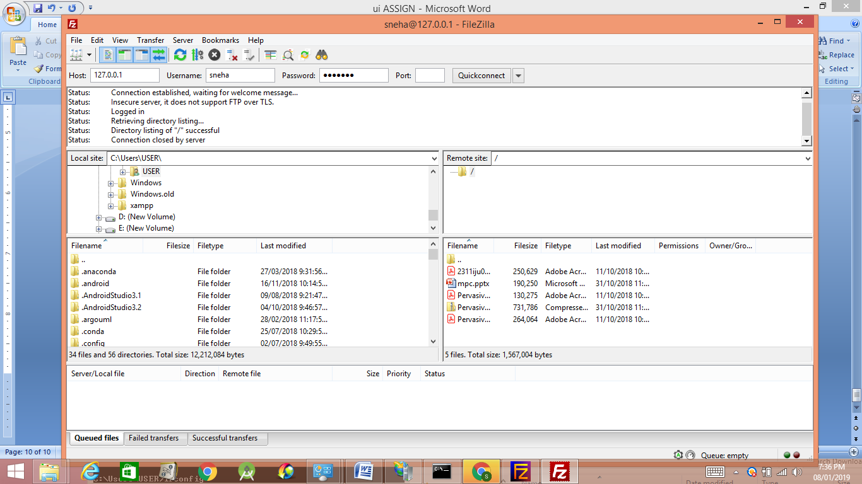

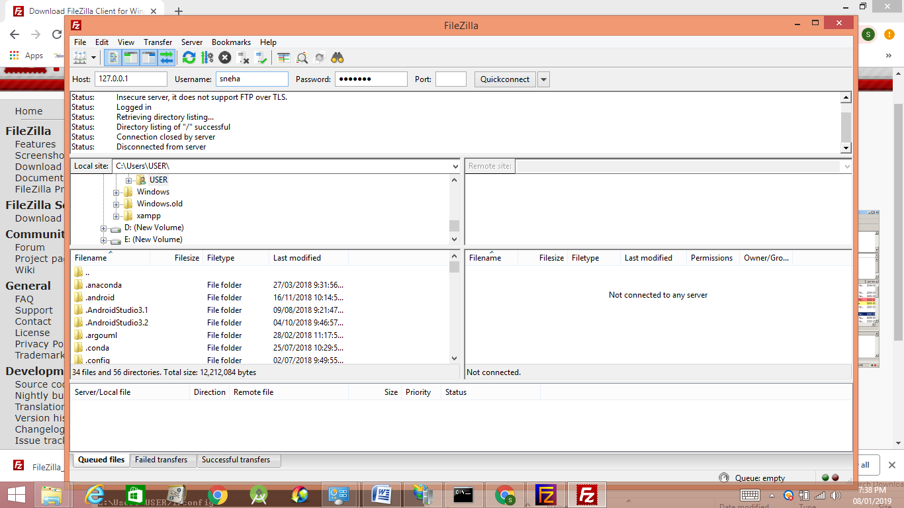

Remote site for user sneha

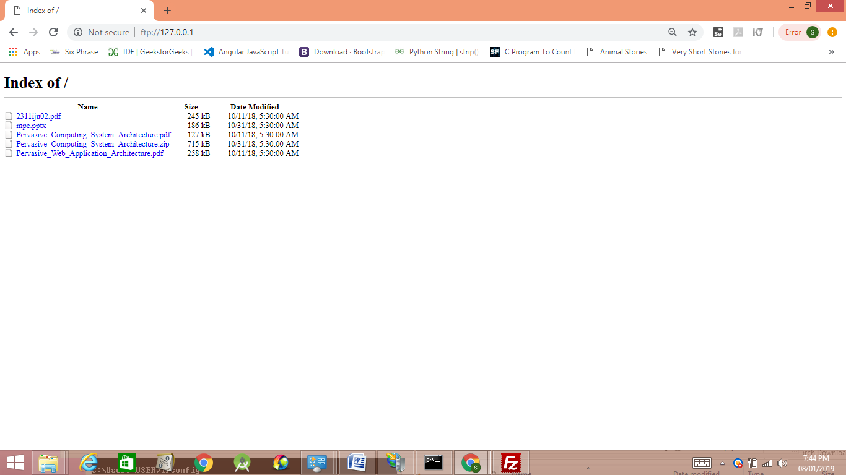
for user priya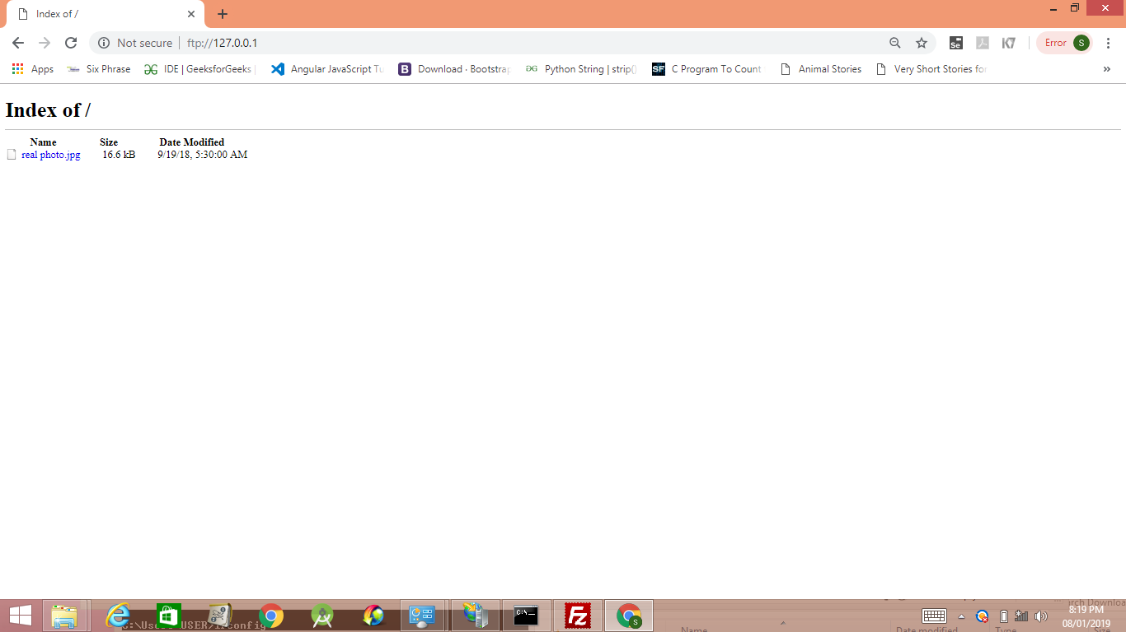
If all worked well, you should see the folder load with no errors.

